George Booth

Oracle E-Business Suite General Ledger Assignment

Date:15th Nov-2024

1. Log into Oracle EBS. Switch the responsibility to System Administrator

Path is Security> User > Define

User:XX_GB_USER password:welcome

1. Password expiration is 60 days.

1. Switch responsibility to General Ledger, Vision Operations (USA) then follow this path

GL >> Setup>> Financial >>  Accounting Setup Manager >> Accounting setups

Then you will be sent to an HTML page and type Vision Op% into the search bar.

Then Click on the pencil under Update Accounting Options

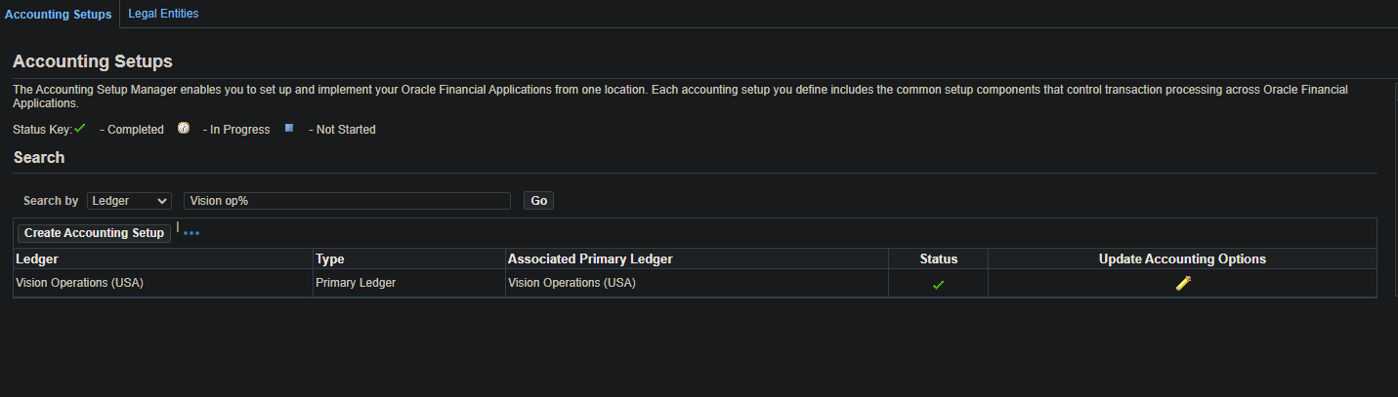

After this click Vision Operations under Primary Ledger

Which will take you to this page that shows the Chart of Accounts and show the 4C Componets

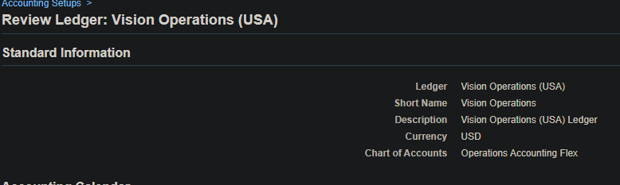

1. The path to find all the Account Code Combinations is GL >> Setups >>Accounts >> combinations. When open press Ctrl + Fn + F11 to query all the combinations

1. To find all journals the path is General Ledger >> Journals >> Enter

Select Payables for the Source and Vision Operations (USA) for the ledger and press Find

1. In journals you select Help at the top of Oracle EBS and choose the Record History which gives you the Data base table name

Path to here is General Ledger >> Journals >> Enter

Table Name is GL_JE_BATCHES_HEADERS_V

1. Source of Manual and Payable in journals

General Ledger >> Journals >> Enter

1. To review posted Journal entries the path is General Ledger >> Journals >> Enter

Then Press Find button, then you can find all Posted Journals in the General Ledger.

1. To find the Chart of Accounts Structure you follow this path GL>> Setup>>Financials >>Flexfields>>Key>>Segments then press F11 and type General Ledger

Then click View>Find then type in Operations Accounting Flex

Then select one and press segments to see the structure

Then Press open on one of the options to see the information about the Segment

Then press Flexfields Qualifiers to see what type of segment it is

1. In the General Ledger responsibly click View tab at the top then select Requests

Once you are here press the Find button which will show a list of requests

1. The common components are the 4C’s

Chart of Accounts is a list of all accounts used by an organization to record financial transactions/how you identify natural account locations

Calendar: Months of the year

Currency: Like USD or GBP

Accounting Method: set of principles that companies are required to follow when they report their financial statements

1. The path to find how many types of accounts is GL >> Setup>> Accounts >> combinations Then press Ctrl + Fn + F11 to see all the different types

Then select the tab at the top View> Find and you can see all the different types of accounts

1. Path GL>> Setup>>Financials >>Flexfields>>Key>>Segments then press F11 and type General Ledger

Then click View>Find then type in Operations Accounting Flex

Then select one and press segments to see the structure

Then Press open on one of the options to see the information about the Segment

Then press Flexfields Qualifiers to see what type of segment it is

